**Big Black Card (BBC ) Admin Manual**

Table of Contents

1. *Introduction*………………………………………. 1

2. *Getting Started*………………………………….. 1

2.1. File Requirements

2.2. Program Execution

3. *Main Menu*…………………………………………. 1

3.1. Add New Account

3.2. Display Account Data

3.3. Add Account Balance

3.4. Deduct Account Balance

3.5. Exit

4. *Add New Account*………………………………. 2

5. *Display Account Data*………………………… 2

6. *Add Account Balance*…………………………. 3

7. *Deduct Account Balance*……………………. 4

8. *Exiting the Program*…………………………… 4

1. Introduction

Welcome to the BBC (Big Black Card) Banking System User Manual. This guide provides instructions on using the BBC COBOL program for basic banking operations.

2. Getting Started

2.1. File Requirements

The program requires a file named "account.txt" located depending on your directory path for storing account information.

2.2. Program Execution

Compile and execute the program file (BBC) in a COBOL environment.

3. Main Menu

After execution, the program presents an admin menu with the following options:

1. Add Account
2. Display Account
3. Add Balance
4. Deduct Balance
5. Exit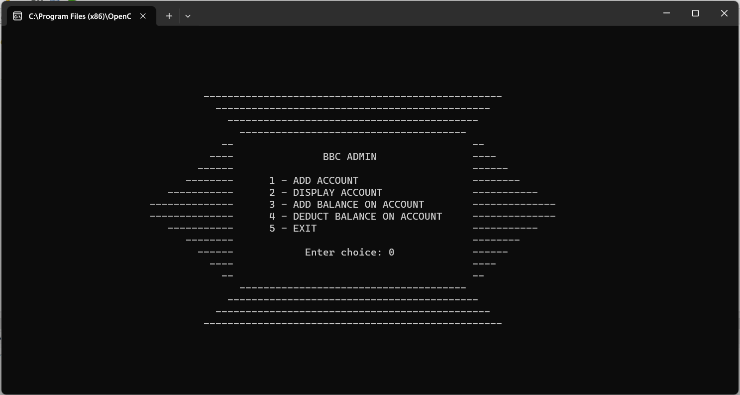

4. Add New Account

Upon creating an account, an automatically generated PIN code will be provided for accessing the account

* Select option 1 from the main menu.
* Enter the required information:
* First Name
* Last Name
* Initial Balance (in PHP)

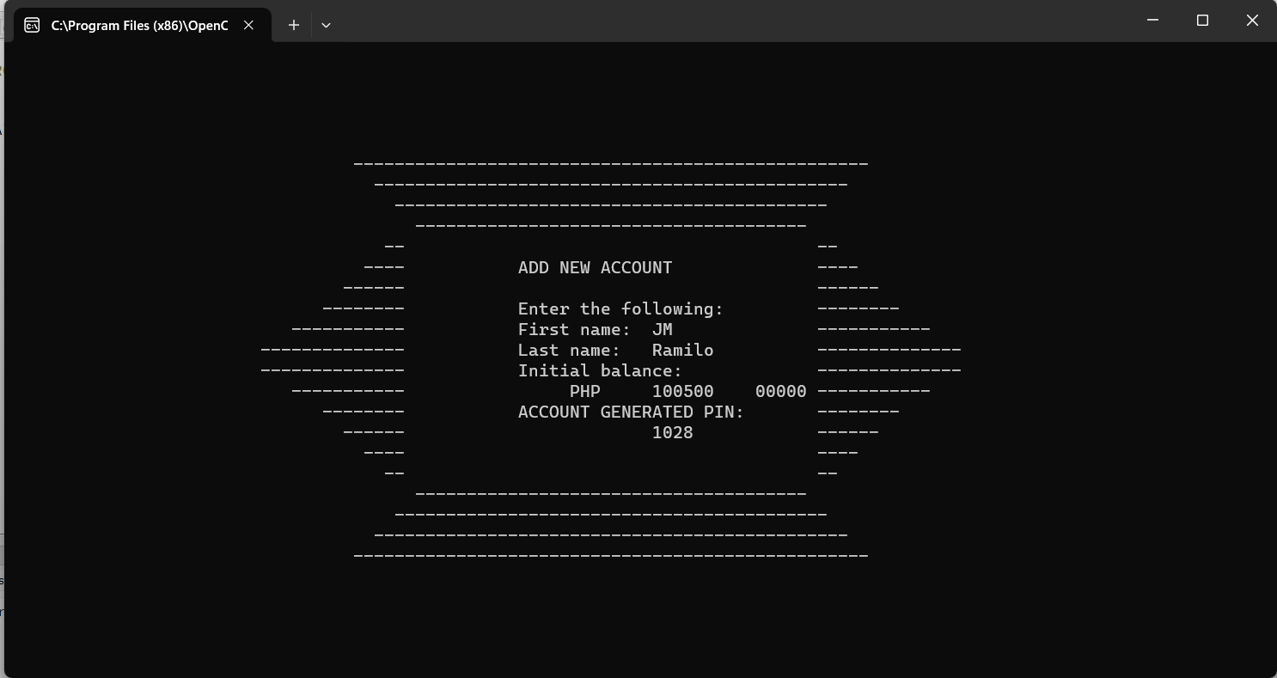

5. Display Account Data

* Select option 2 from the main menu.
* Enter the account PIN when prompted.
* View the displayed account details, including name, balance, and PIN.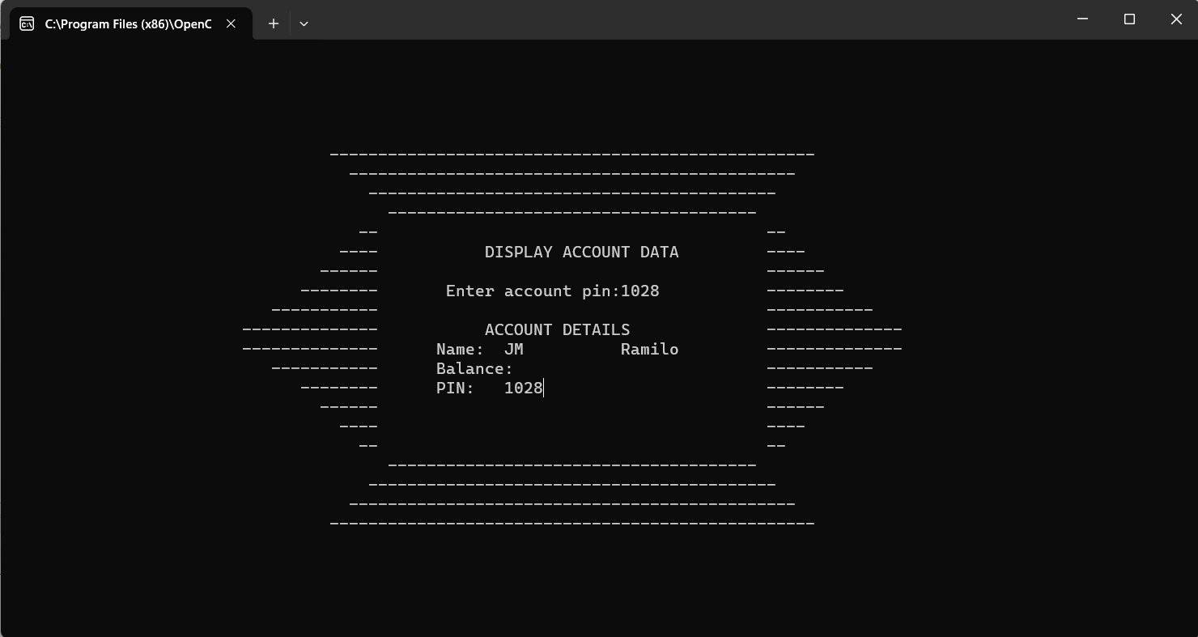

6. Add Account Balance

Upon adding a balance, the account's current balance will also be updated

* Select option 3 from the main menu.
* Enter the account PIN when prompted.
* View the current balance.
* Enter the amount to add to the account balance.

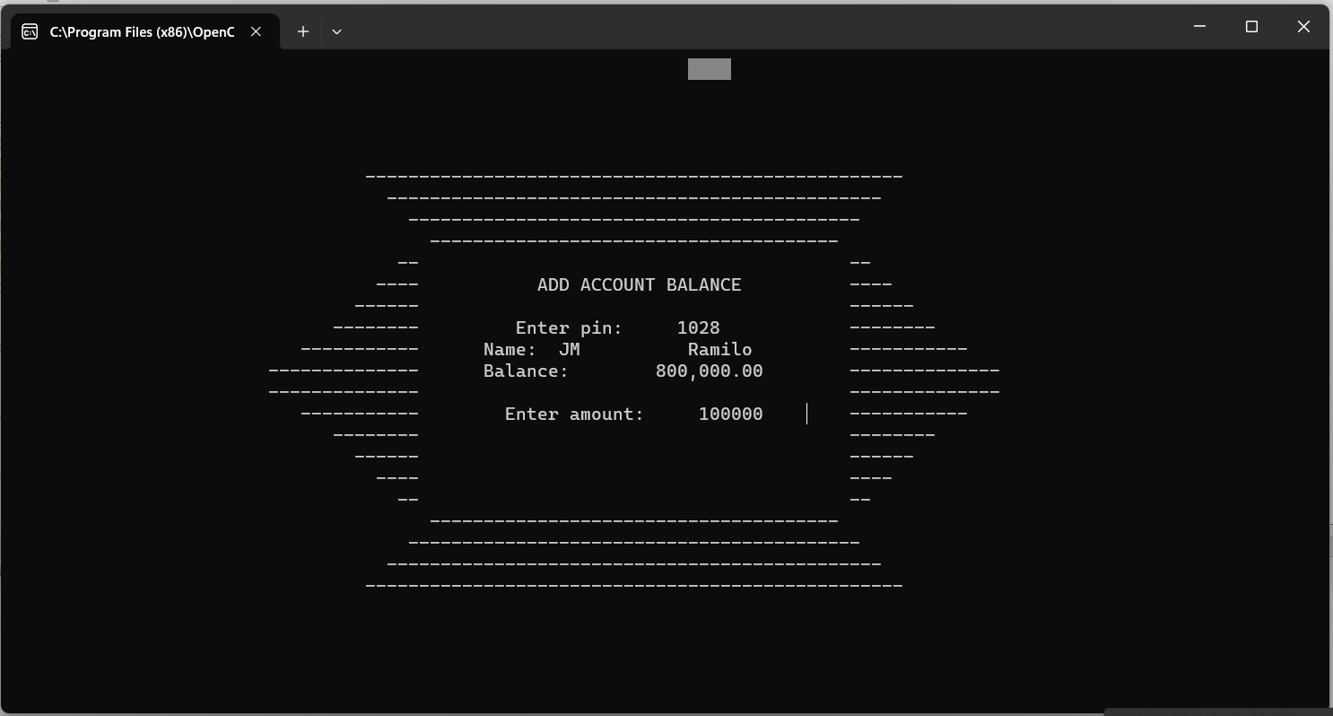

7. Deduct Account Balance

* Select option 4 from the main menu.
* Enter the account PIN when prompted.
* View the current balance.
* Enter the amount to deduct from the account balance.
* Input validation ensures the amount does not exceed the current balance.

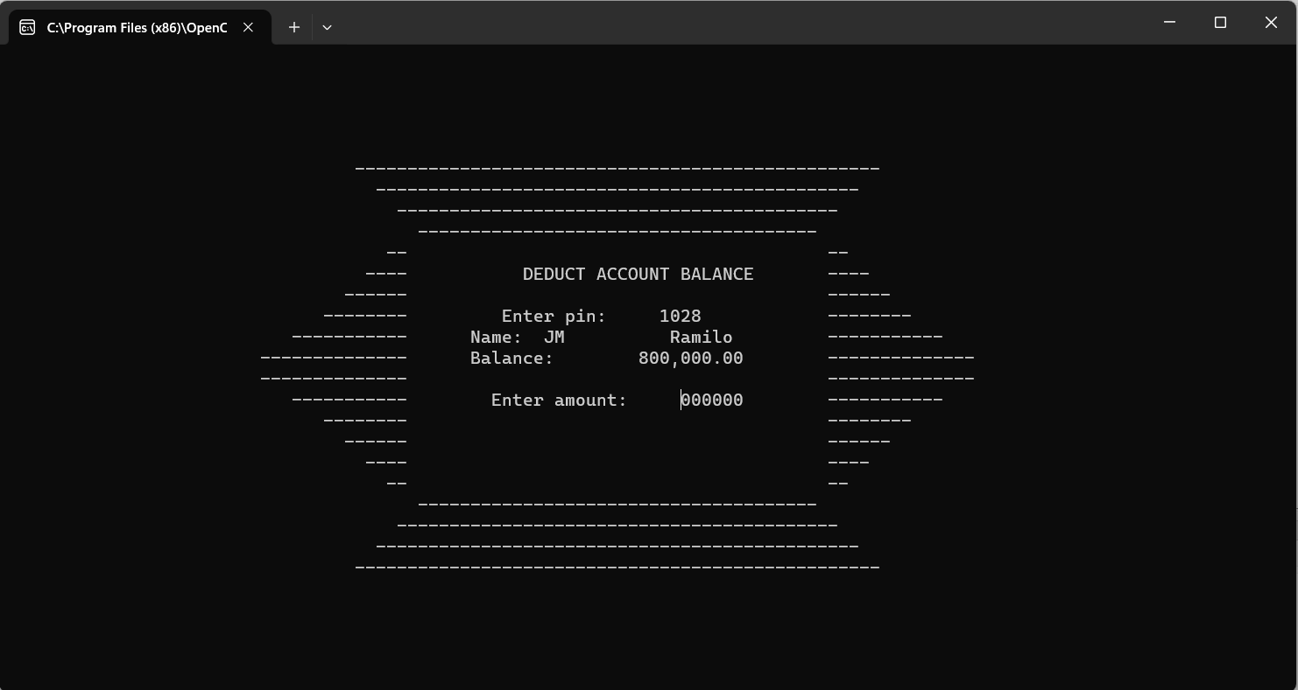

8. Exiting the Program

- Select option 5 from the main menu to exit the program.